|  |  |  |
| --- | --- | --- |
|  | **SGE**  **UD 2. Práctica 3.2** | **C:\Users\profesor\AppData\Local\Microsoft\Windows\INetCache\Content.MSO\11105154.tmp** |
| **Tema 2. Instalación y configuración de sistemas ERP - CRM** | | |
|  | | |

# Desarrollador principiante

# ****Objetivo:**** Aprenda los aspectos básicos sobre el desarrollo de aplicaciones en Salesforce Platform.

**Paso 1 . Inicia sesión en la plataforma de formación Trailforce.**

<https://trailhead.salesforce.com/es>

# ****Paso 2.** Modelado de datos**

<https://trailhead.salesforce.com/es/content/learn/modules/data_modeling>

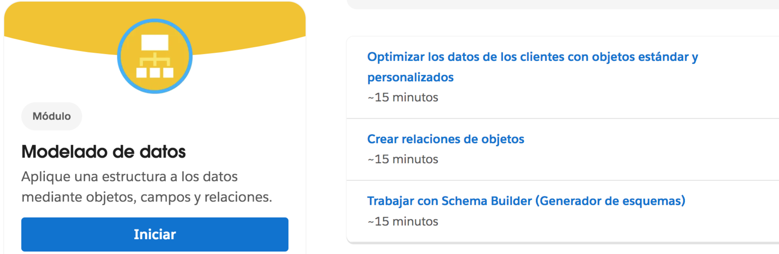

**2.1** [**Optimizar los datos de los clientes con objetos estándar y personalizados**](https://trailhead.salesforce.com/es/content/learn/modules/data_modeling/objects_intro)

**2.2** [**Crear relaciones de objetos**](https://trailhead.salesforce.com/es/content/learn/modules/data_modeling/object_relationships)

**2.3** [**Trabajar con Schema Builder (Generador de esquemas**](https://trailhead.salesforce.com/es/content/learn/modules/data_modeling/schema_builder)**)** 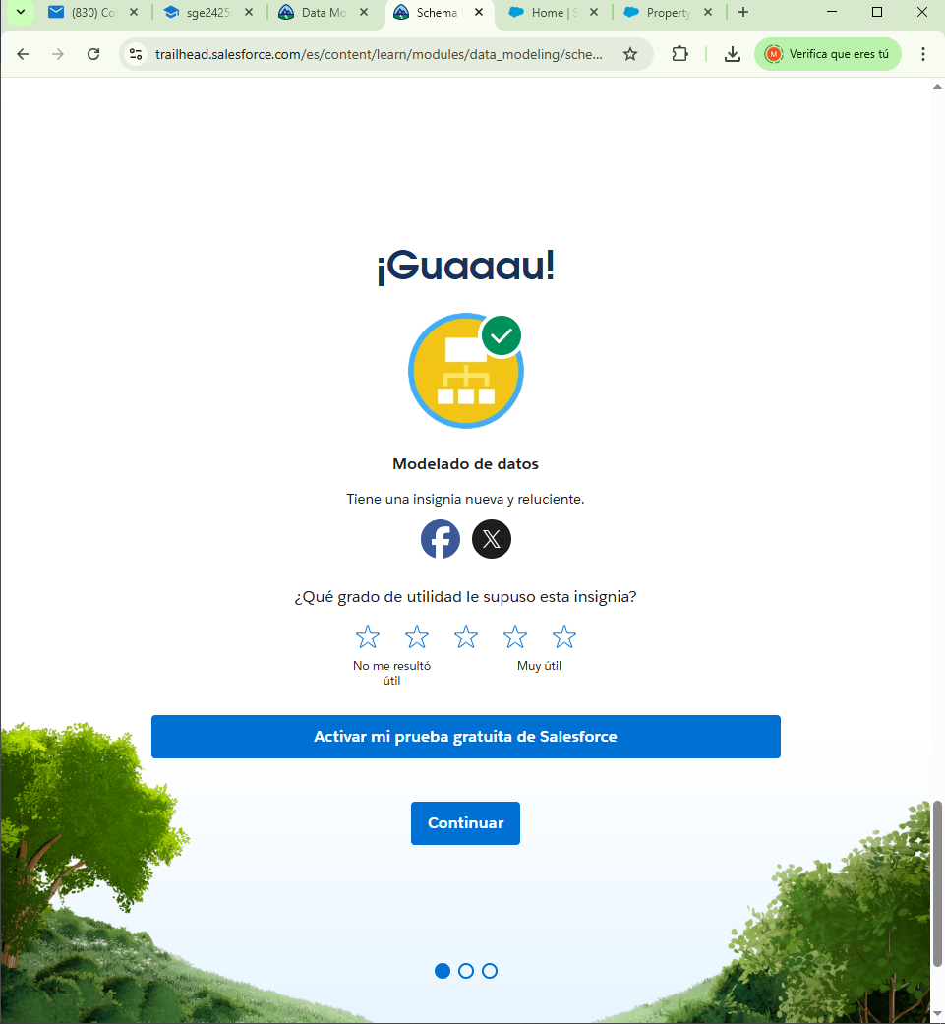

**Paso 3. Ruta desarrollador principiante**

<https://trailhead.salesforce.com/es/content/learn/trails/force_com_dev_beginner>

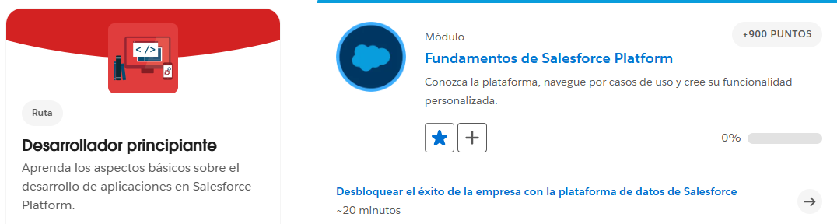

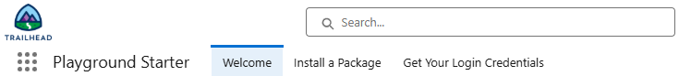

**3.1. Fundamentos de Salesforce Platform NO LO HACEMOS**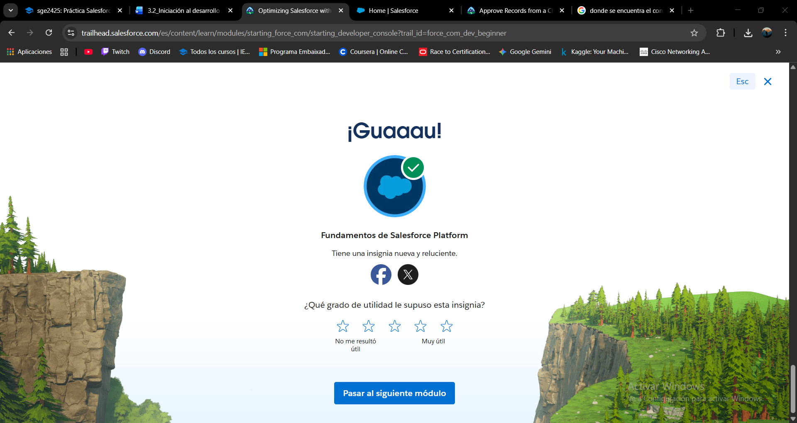

**3.2. Fundamentos de desarrollo de la plataforma**

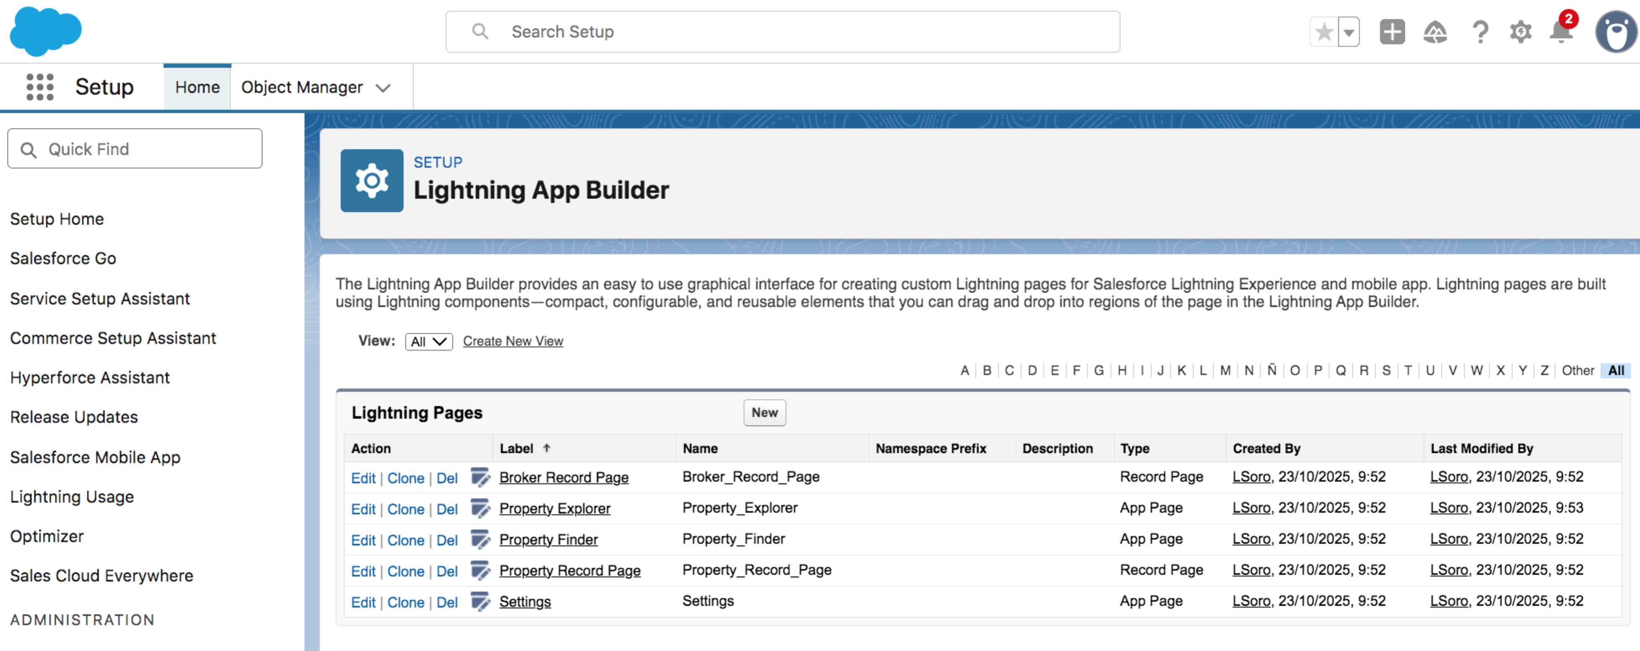

**3.2.1** [**Información general sobre Salesforce Platform**](https://trailhead.salesforce.com/es/content/learn/modules/platform-development-basics/get-started-with-the-salesforce-platform-01?trail_id=force_com_dev_beginner)

**3.2.2** [**Desarrollar sin programar**](https://trailhead.salesforce.com/es/content/learn/modules/platform-development-basics/develop-without-code-01?trail_id=force_com_dev_beginner)

**3.2.3** [**Programar con lenguajes de Salesforce**](https://trailhead.salesforce.com/es/content/learn/modules/platform-development-basics/code-with-salesforce-languages-01?trail_id=force_com_dev_beginner)

**3.2.4** [**Ampliar la plataforma Salesforce**](https://trailhead.salesforce.com/es/content/learn/modules/platform-development-basics/extend-the-salesforce-platform-01?trail_id=force_com_dev_beginner)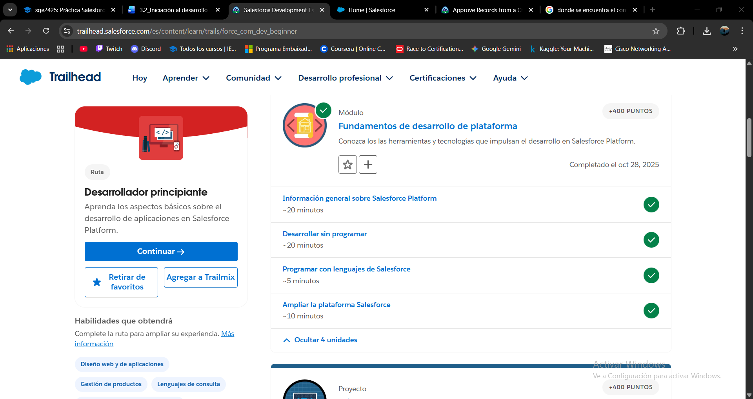

**3.3 Conceptos básicos de form builder**

<https://trailhead.salesforce.com/es/content/learn/modules/flow-basics?trail_id=build-flows-with-flow-builder>

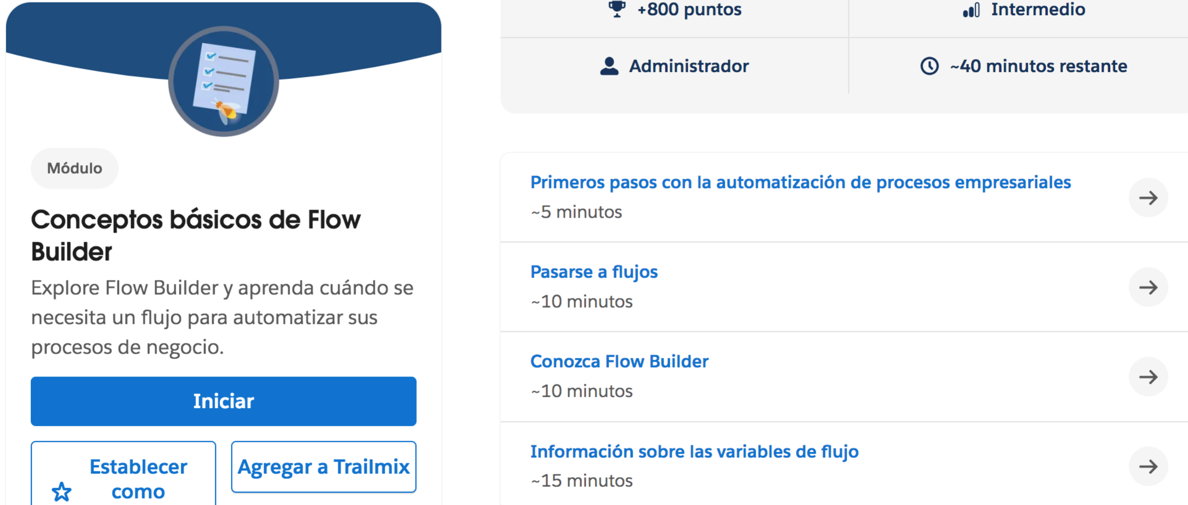

[**Primeros pasos con la automatización de procesos empresariales**](https://trailhead.salesforce.com/es/content/learn/modules/flow-basics/get-started-with-flows?trail_id=build-flows-with-flow-builder)

[**Pasarse a flujos**](https://trailhead.salesforce.com/es/content/learn/modules/flow-basics/go-with-the-flow-th?trail_id=build-flows-with-flow-builder)

[**Conozca Flow Builder**](https://trailhead.salesforce.com/es/content/learn/modules/flow-basics/meet-flow-builder?trail_id=build-flows-with-flow-builder)

[**Información sobre las variables de flujo**](https://trailhead.salesforce.com/es/content/learn/modules/flow-basics/learn-about-flow-variables?trail_id=build-flows-with-flow-builder)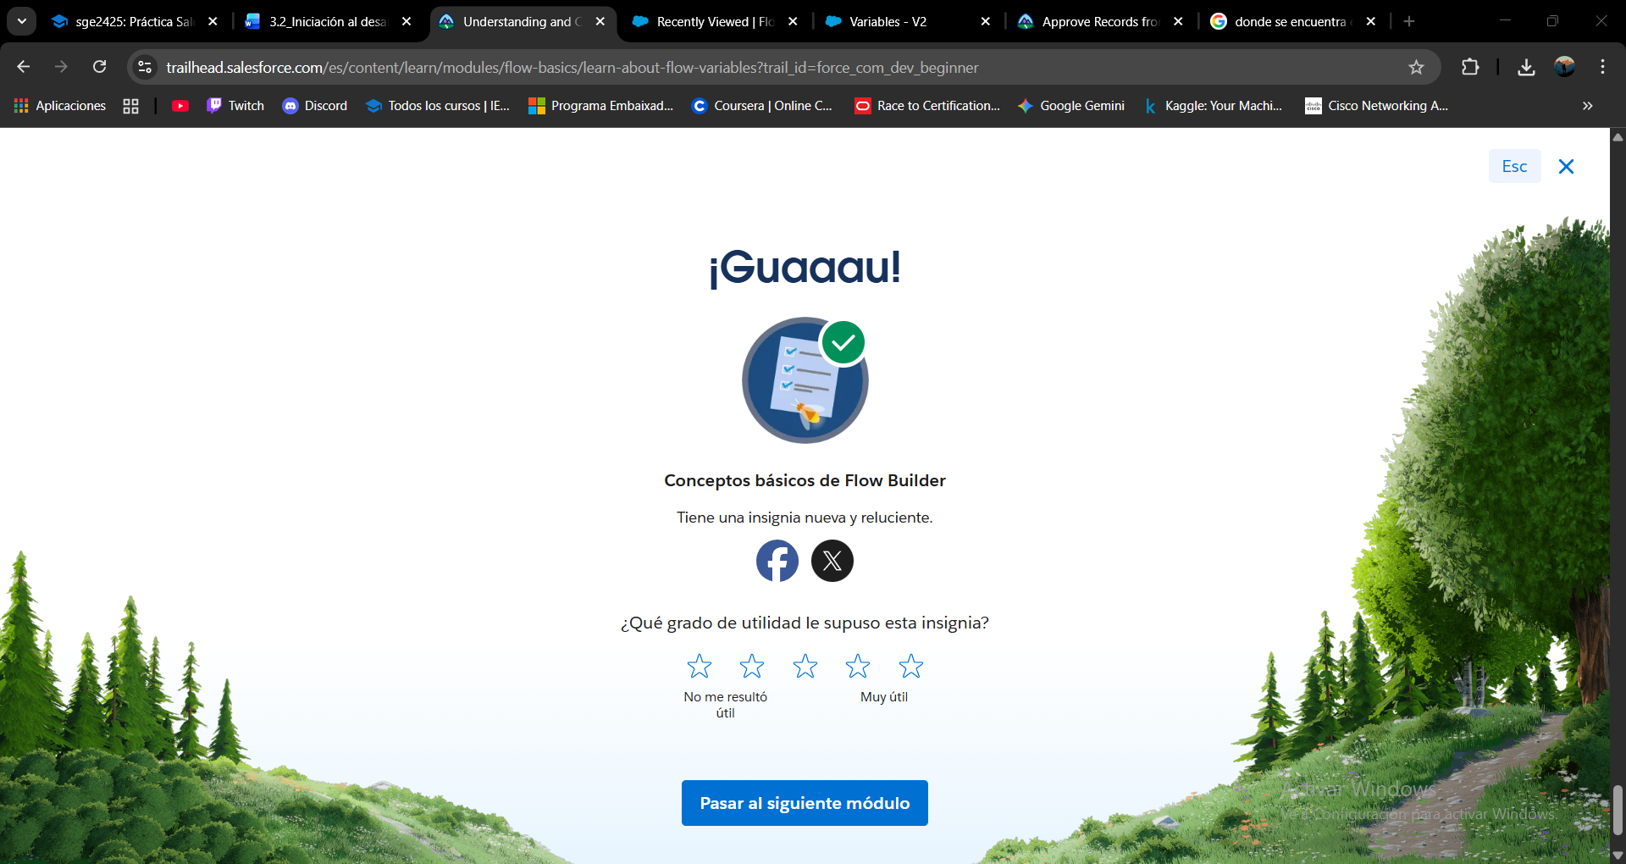

**3.4 Primeros pasos con Salesforce Development**

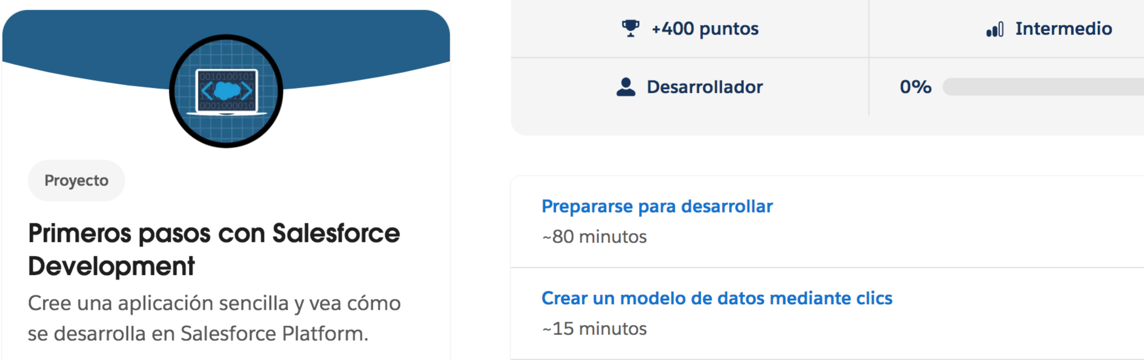

[**Prepararse para desarrollar**](https://trailhead.salesforce.com/es/content/learn/projects/get-started-with-salesforce-development/get-ready-to-develop?trail_id=force_com_dev_beginner) **( solo hacemos aquellos pasos que no hayamos completado hasta ahora)**

[**Crear un modelo de datos mediante clics**](https://trailhead.salesforce.com/es/content/learn/projects/get-started-with-salesforce-development/create-a-data-model-using-clicks?trail_id=force_com_dev_beginner)

[**Escribir lógica de negocio en Apex**](https://trailhead.salesforce.com/es/content/learn/projects/get-started-with-salesforce-development/write-business-logic-in-apex?trail_id=force_com_dev_beginner)

[**Crear un componente de interfaz de usuario reutilizable con Lightning Web Components**](https://trailhead.salesforce.com/es/content/learn/projects/get-started-with-salesforce-development/build-reusable-ui-component-with-lightning-web-components?trail_id=force_com_dev_beginner)